**Question 1**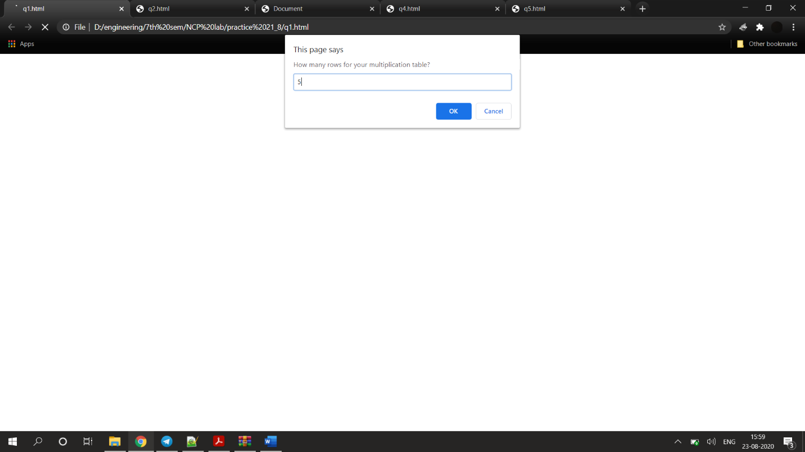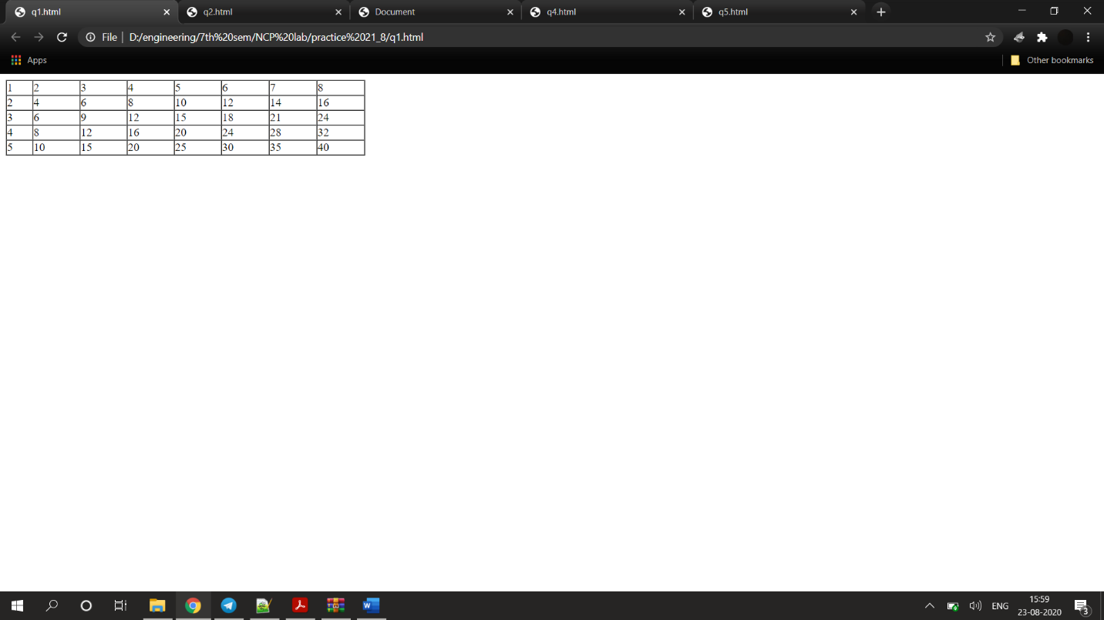

<html>

<head>

<script type="text/javascript">

var rows = prompt("How many rows for your multiplication table?");

var cols = prompt("How many columns for your multiplication table?");

if(rows == "" || rows == null)

rows = 5;

if(cols== "" || cols== null)

cols = 5;

createTable(rows, cols);

function createTable(rows, cols)

{

var j=1;

var output = "<table border='1' width='500' cellspacing='0'cellpadding='0'>";

for(i=1;i<=rows;i++)

{

output = output + "<tr>";

while(j<=cols)

{

output = output + "<td>" + i*j + "</td>";

j = j+1;

}

output = output + "</tr>";

j = 1;

}

output = output + "</table>";

document.write(output);

}

</script>

</head>

<body>

</body>

</html>

**Question 2**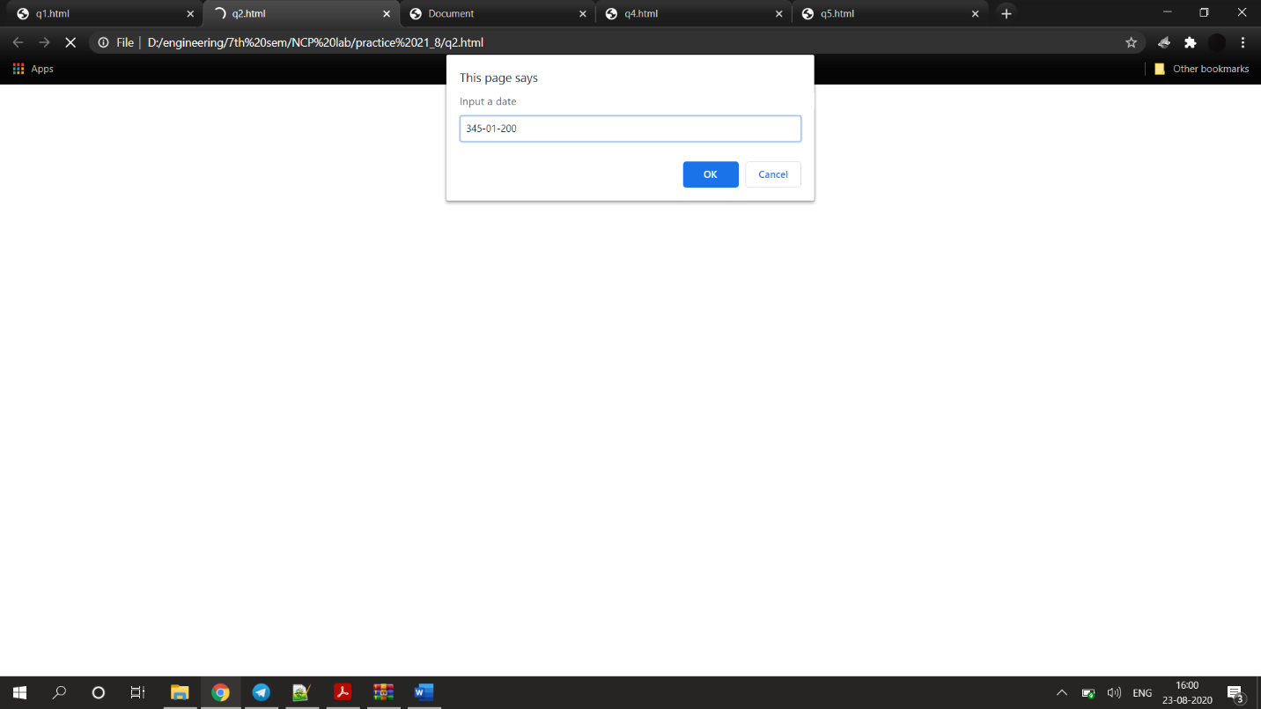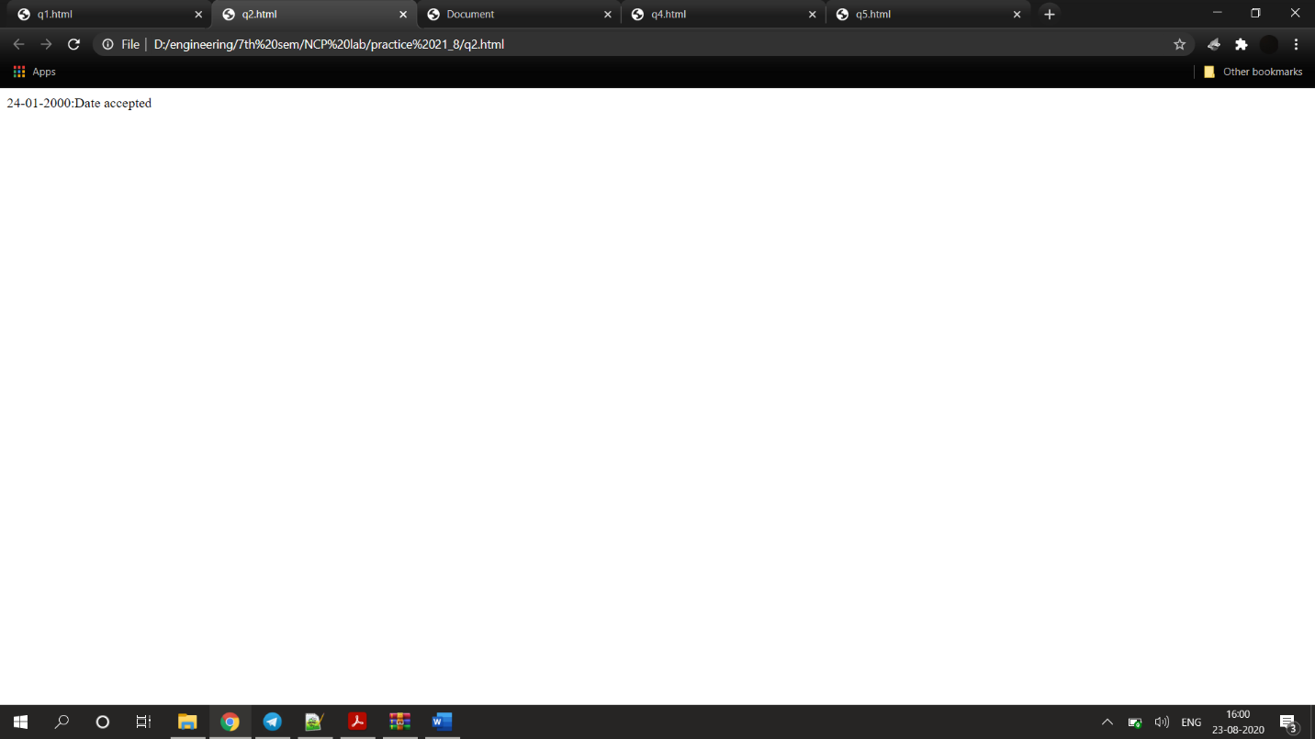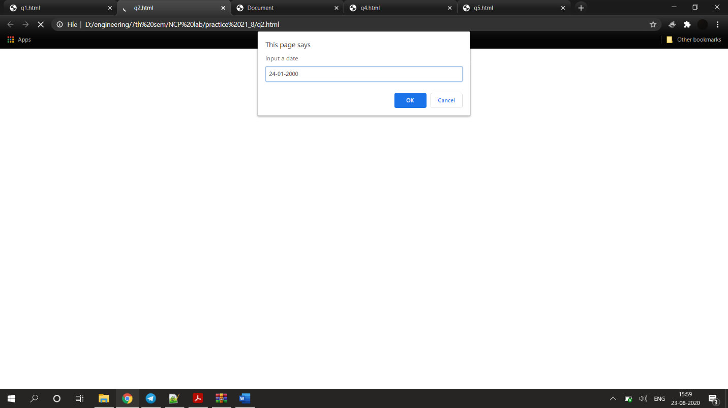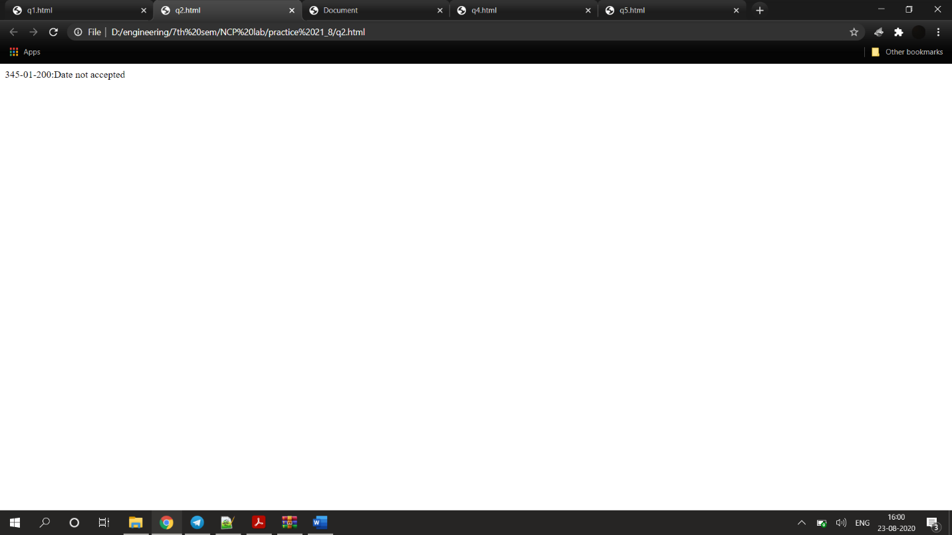

<!DOCTYPE html>

<html>

<script type = "text/javascript">

var input;

var pattern =/^([0-9]{2})\-([0-9]{2})\-([0-9]{4})$/;

input=prompt("Input a date")

if(pattern.test(input)){

document.write(input+":Date accepted")

}else{

document.write(input+":Date not accepted")

}

</script>

</html>

**Question 3**

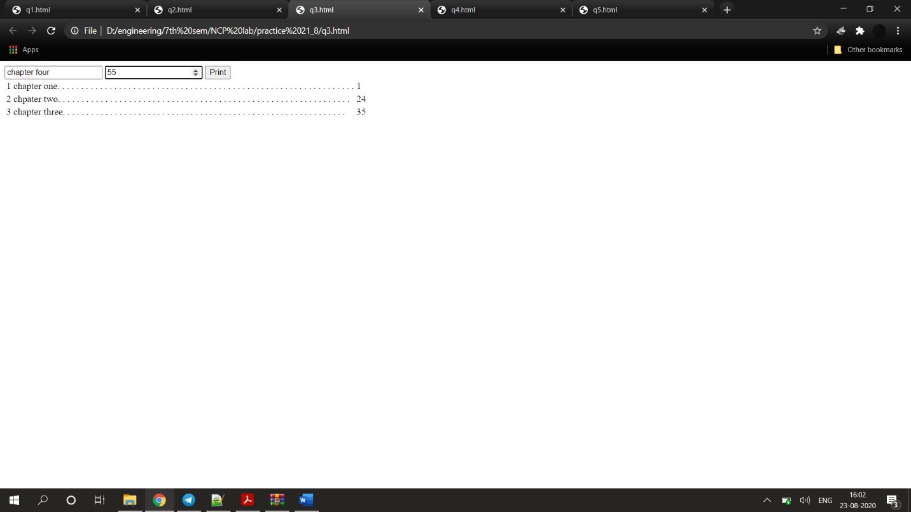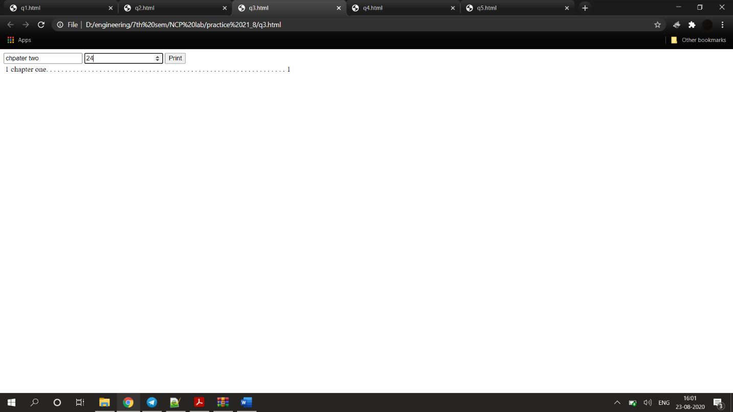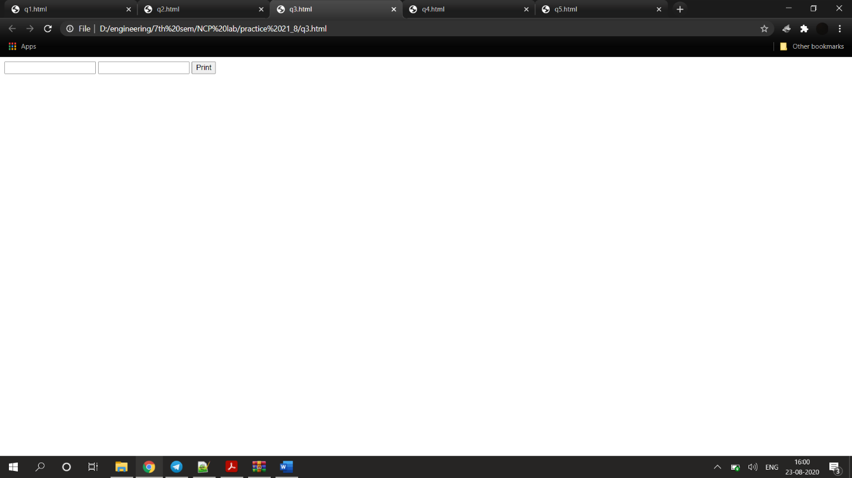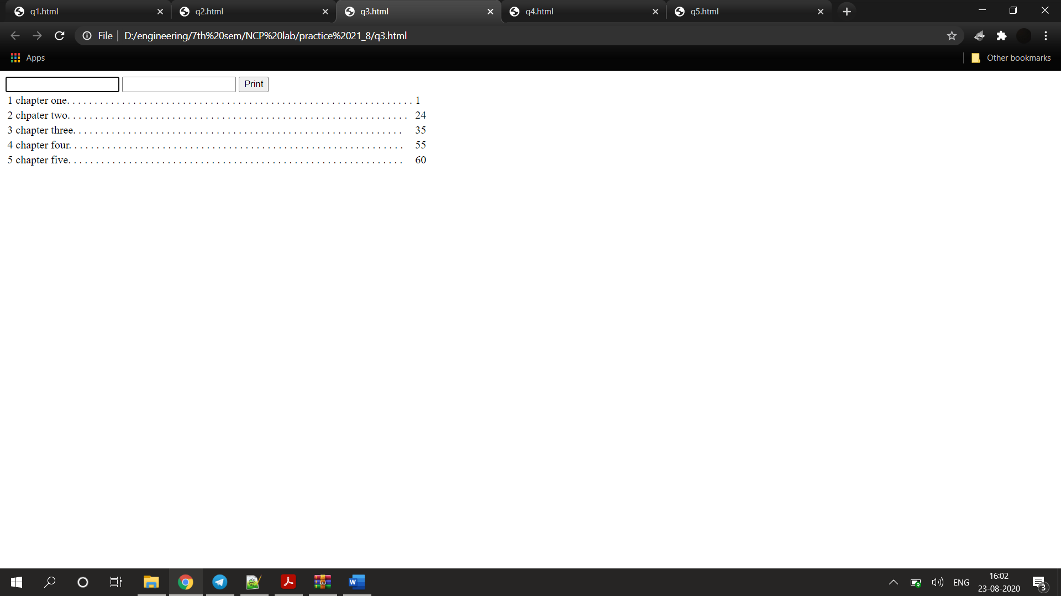

<!DOCTYPE html>

<html lang="en">

<body>

<input type="text" name="chapter" id="chapter">

<input type="number" name="page" id="page">

<input type="button" name="submit" id="submit" value="Print" onclick="generatePageNumber()">

<table style="table-layout: fixed;" id="list" >

</table>

<script>

document.addEventListener("keyup", function (event) {

if (event.keyCode === 13) {

event.preventDefault();

generatePageNumber()

}

});

var arr=[]

function generatePageNumber()

{

var c_name=document.getElementById("chapter").value

var pg= document.getElementById("page").value

if(c_name==""||pg=="")

{

alert("Enter data")

}

else{

arr.push({ chap: c_name, pg: pg })

arr = arr.sort(function (a, b) {

return parseInt(a.pg) - parseInt(b.pg);

})

var output = ""

for (var i = 0; i < arr.length; i++) {

output += "<tr><td>"+(i+1)+"</td><td>"

var slen = arr[i].chap.length

// console.log(slen+" "+arr[i].pg.length)

output += arr[i].chap

for (var j = 0; j < (75 - (slen + arr[i].pg.length)); j++) {

output += ". "

}

output += "</td><td>"+arr[i].pg + "</td></tr><br>"

}

document.getElementById("list").innerHTML = output

document.getElementById("chapter").value=""

document.getElementById("chapter").select()

document.getElementById("page").value=""

}

}

</script>

</body>

</html>

**Question 4**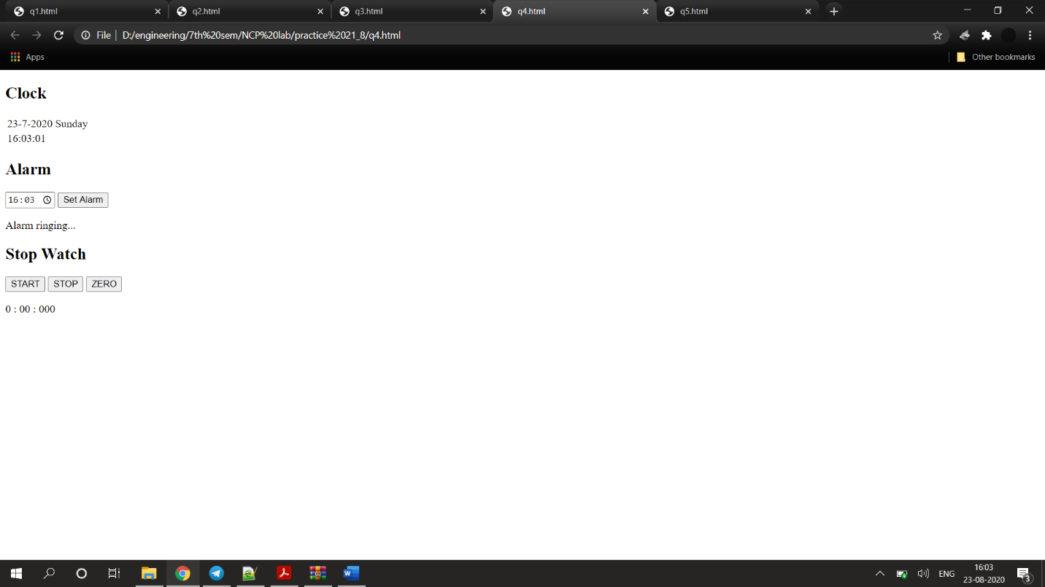

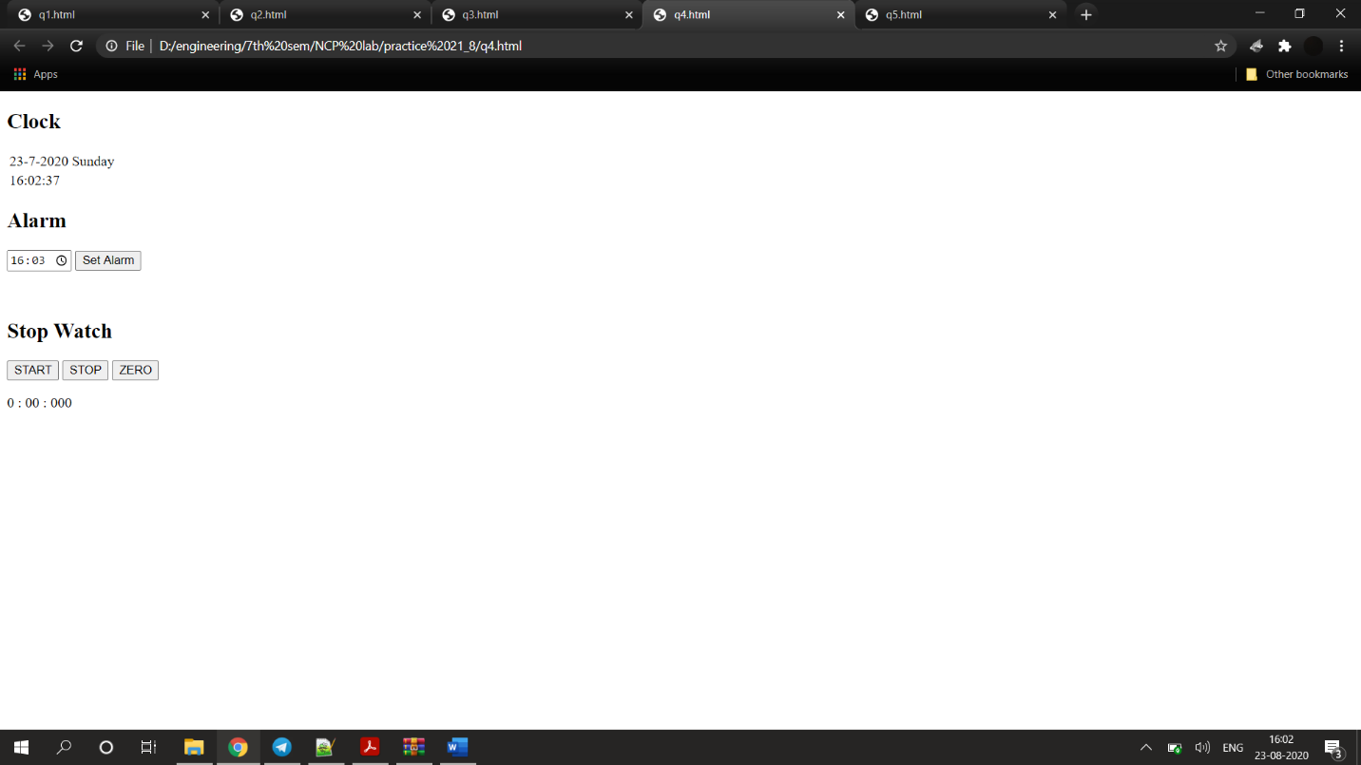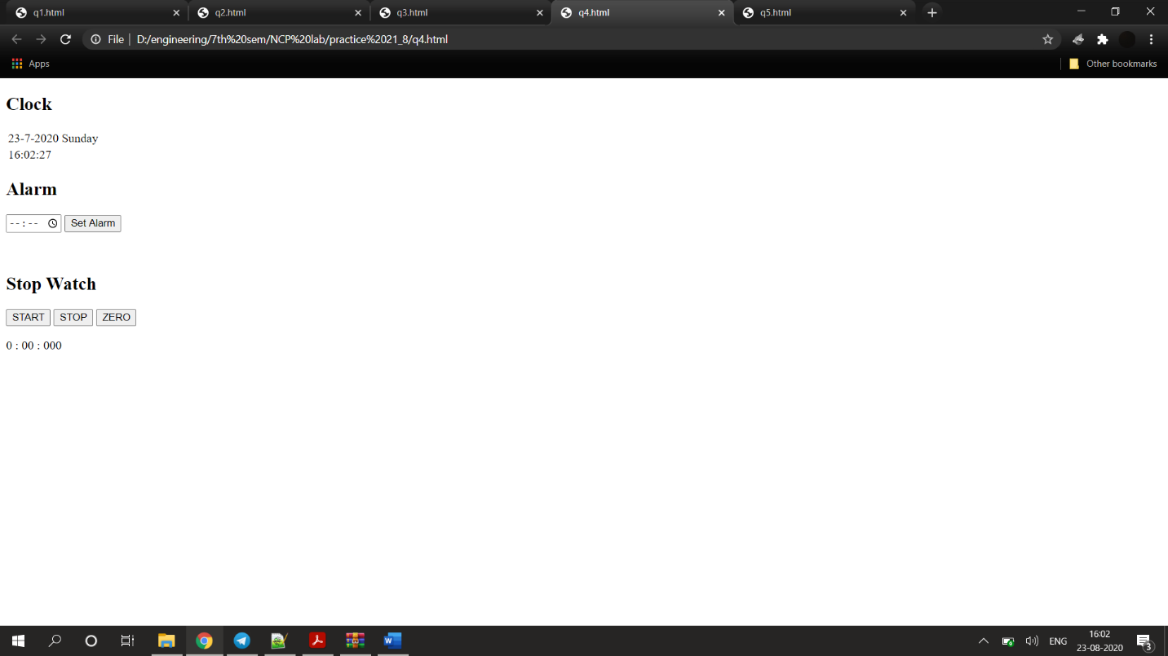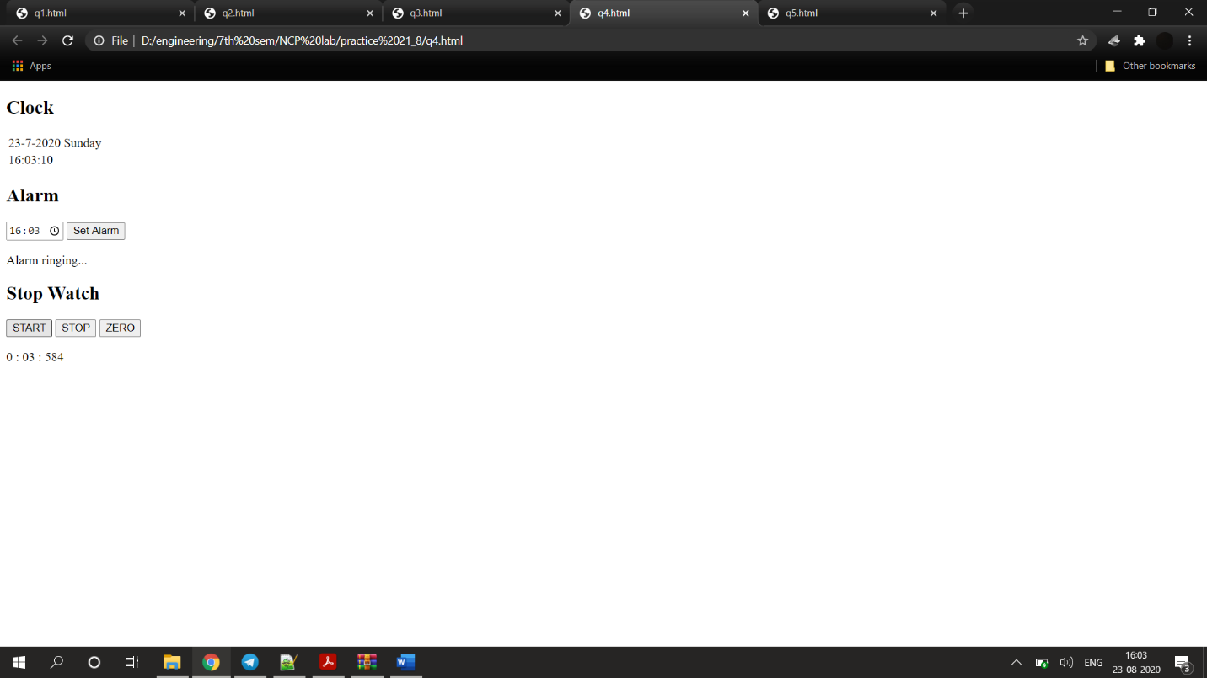

<!DOCTYPE html>

<html>

<body style="font-family:'Times New Roman' " onload="startTime()">

<h2>Clock</h2>

<table>

<thead>

<tr>

<td><div id="date"></div></td>

<td><div id="day"></div></td>

</tr>

</thead>

<tbody>

<tr>

<td><div id="time"></div></td>

</tr>

</tbody>

</table>

<h2>Alarm</h2>

<input type="time" id="alarmtime";" onkeyup="stopAlarm()">

<input type="submit" id="setalarm" value="Set Alarm" onclick="setAlarmFunc()">

<p id="alarmindicator" style="visibility: hidden;">Alarm ringing...</p>

<h2>Stop Watch</h2>

<input type="button" onclick="startWatch()" value="START" />

<input type="button" onclick="stopWatch()" value="STOP" />

<input type="button" onclick="resetWatch()" value="ZERO" />

<p id="res"><span id="min">0</span> : <span id="sec">00</span> : <span id="msec">000</span></p>

<script>

var setAlarm=false

function setAlarmFunc()

{

console.log("Alarm On");

setAlarm=true

}

function stopAlarm()

{

setAlarm=false

}

let week=["Sunday","Monday","Tuesday","Wednesday","Thursday","Friday","Saturday"]

function startTime() {

var today = new Date();

var h = today.getHours();

var m = today.getMinutes();

var s = today.getSeconds();

m = checkTime(m);

s = checkTime(s);

document.getElementById("date").innerText=today.getDate()+"-"+today.getMonth()+"-"+today.getFullYear()

document.getElementById("day").innerText=week[today.getDay()]

document.getElementById('time').innerHTML =

h + ":" + m + ":" + s;

var t = setTimeout(startTime, 500);

if(setAlarm)

{

var hcheck=document.getElementById("alarmtime").value

var currtimevalue=checkTime(today.getHours())+":"+checkTime(today.getMinutes())

if(hcheck==currtimevalue)

{

document.getElementById("alarmindicator").style.visibility="visible"

}

else{

document.getElementById("alarmindicator").style.visibility = "hidden"

}

}

}

function checkTime(i) {

if (i < 10) { i = "0" + i };

return i;

}

var timer = null;

var min_txt = document.getElementById("min");

var min = Number(min_txt.innerHTML);

var sec_txt = document.getElementById("sec");

var sec = Number(sec_txt.innerHTML);

var msec_txt = document.getElementById("msec");

var msec = Number(msec_txt.innerHTML);

function stopTimeMilliseconds(timer) {

if (timer) {

clearInterval(timer);

return timer;

}

else return timer;

}

function startTimeMilliseconds() {

var currDate = new Date();

return currDate.getTime();

}

function getElapsedTimeMilliseconds(startMilliseconds) {

if (startMilliseconds > 0) {

var currDate = new Date();

elapsedMilliseconds = (currDate.getTime() - startMilliseconds);

return elapsedMilliseconds;

}

else {

return elapsedMilliseconds = 0;

}

}

function startWatch() {

timer = stopTimeMilliseconds(timer);

var startMilliseconds = startTimeMilliseconds();

timer = setInterval(function () {

var elapsedMilliseconds = getElapsedTimeMilliseconds(startMilliseconds);

if (msec < 10) {

msec_txt.innerHTML = "00" + msec;

}

else if (msec < 100) {

msec_txt.innerHTML = "0" + msec;

}

else {

msec_txt.innerHTML = msec;

}

if (sec < 10) {

sec_txt.innerHTML = "0" + sec;

}

else {

sec_txt.innerHTML = sec;

}

min_txt.innerHTML = min;

msec = elapsedMilliseconds;

if (min >= 59 && sec >= 59 && msec > 900) {

timer = stopTimeMilliseconds(timer);

return true;

}

if (sec > 59) {

sec = 0;

min++;

}

if (msec > 999) {

msec = 0;

sec++;

startWatch();

}

}, 10);

}

function stopWatch() {

timer = stopTimeMilliseconds(timer);

return true;

}

function resetWatch() {

timer = stopTimeMilliseconds(timer);

msec_txt.innerHTML = "000";

msec = 0;

sec_txt.innerHTML = "00";

sec = 0;

min_txt.innerHTML = "0";

min = 0;

return true;

}

</script>

</body>

</html>

**Question 5**

<!DOCTYPE html>

<html lang="en">

<body>

<img src="" id="image" style="height: 300px; width: auto;">

<h3 id="desc"></h3>

<button id="gen" onclick="thefunc()">Randomize</button>

<table>

<tr>

<td>MSD</td>

<td id="1">0</td>

</tr>

<tr>

<td>Kohli</td>

<td id="2">0</td>

</tr>

<tr>

<td>Raina</td>

<td id="3">0</td>

</tr>

<tr>

<td>Sachin</td>

<td id="4">0</td>

</tr>

<tr>

<td>Dravid</td>

<td id="5">0</td>

</tr>

</table>

<script>

var n = {"1": 0,"2": 0,"3": 0,"4": 0,"5": 0,}

var texts = ["MSD","Kohli","Raina","Sachin","Dravid"]

var images = [

"msd.jpg","kohli.jpg","raina.jpg","sachin.jpg","dravid.jpg"

]

function thefunc()

{

for(var i=0;i<1;i++)

{

setTimeout(function () {

var rand = Math.floor(Math.random() * 5)

if (document.getElementById(String(rand + 1)).innerText == "0") {

document.getElementById(String(rand + 1)).innerText = "1"

n[String(rand + 1)] = 1

} else {

document.getElementById(String(rand + 1)).innerText = String(parseInt(document.getElementById(String(rand + 1)).innerText) + 1)

n[String(rand + 1)] = parseInt(document.getElementById(String(rand + 1)).innerText) + 1

}

document.getElementById('desc').innerText = texts[rand]

document.getElementById("image").src = images[rand]

}, 2000 * i);

}

}

</script>

</body>

</html>

